Software Development Life Cycle (SDLC)
The Software Development Life Cycle (SDLC) is a structured process that development teams use to design, build, test, deploy, and maintain high-quality software in a cost-effective and time-efficient manner. The primary goal of the SDLC is to minimize project risks through careful forward planning, ensuring the final software meets or exceeds customer expectations.
1. The Core Phases of the SDLC
The SDLC typically outlines a series of steps that divide the software development process into manageable tasks. While the exact number and names vary, the process includes the following common phases:
1. Planning (or Conceptualization)
- Purpose: Define the software's purpose, scope, goals, and objectives.
- Activities: Conduct feasibility studies (technical, financial, operational), resource estimation, scheduling, and risk analysis.
- Deliverables: Project Plan, initial cost estimates, and resource requirements.
2. Requirements Analysis (or Analysis)
- Purpose: Identify, gather, and document the precise requirements of the final users and stakeholders.
- Activities: Collect information through interviews, surveys, and focus groups, then analyze and validate it to ensure feasibility and comprehensiveness.
- Deliverables: Software Requirement Specification (SRS) document, which details the software's functions, features, and functionalities.
3. Design
- Purpose: Create the software's overall architecture and define how all components will function and interact.
- Activities: Determine technology choices, create system specifications, and design the database, data structures, and user interface.
  - High-level design (HLD) defines the overall architecture.
  - Low-level design (LLD) describes the working of each component.
- Deliverables: Design Document Specification (DDS) or Software Design Document (SDD).
4. Implementation (or Coding/Development)
- Purpose: Translate the design specifications and system requirements into actual, functional code.
- Activities: Developers write code following established standards, use programming tools (compilers, debuggers), and integrate different components (front-end, middleware, back-end).
- Deliverables: Functional software prototype or initial working product.
5. Testing
- Purpose: Evaluate the developed software to assess whether it meets customer requirements and quality standards.
- Activities: Run various tests, including unit testing (individual modules), integration testing (components working together), system testing (overall performance), and user acceptance testing.
- Deliverables: Test reports, refined and optimized software, and defect fixes.
6. Deployment (or Release)
- Purpose: Officially release the finished software into the production environment for end-users.
- Activities: Packaging, configuring the environment, installing the software, and potentially conducting a pilot or beta launch.
7. Maintenance
- Purpose: Ongoing support to ensure the software remains functional, relevant, and secure over time.
- Activities: Fixing residual bugs, resolving customer issues, adding updates, monitoring system performance, and managing future changes.
- Deliverables: Patches, updates, and new versions of the software.
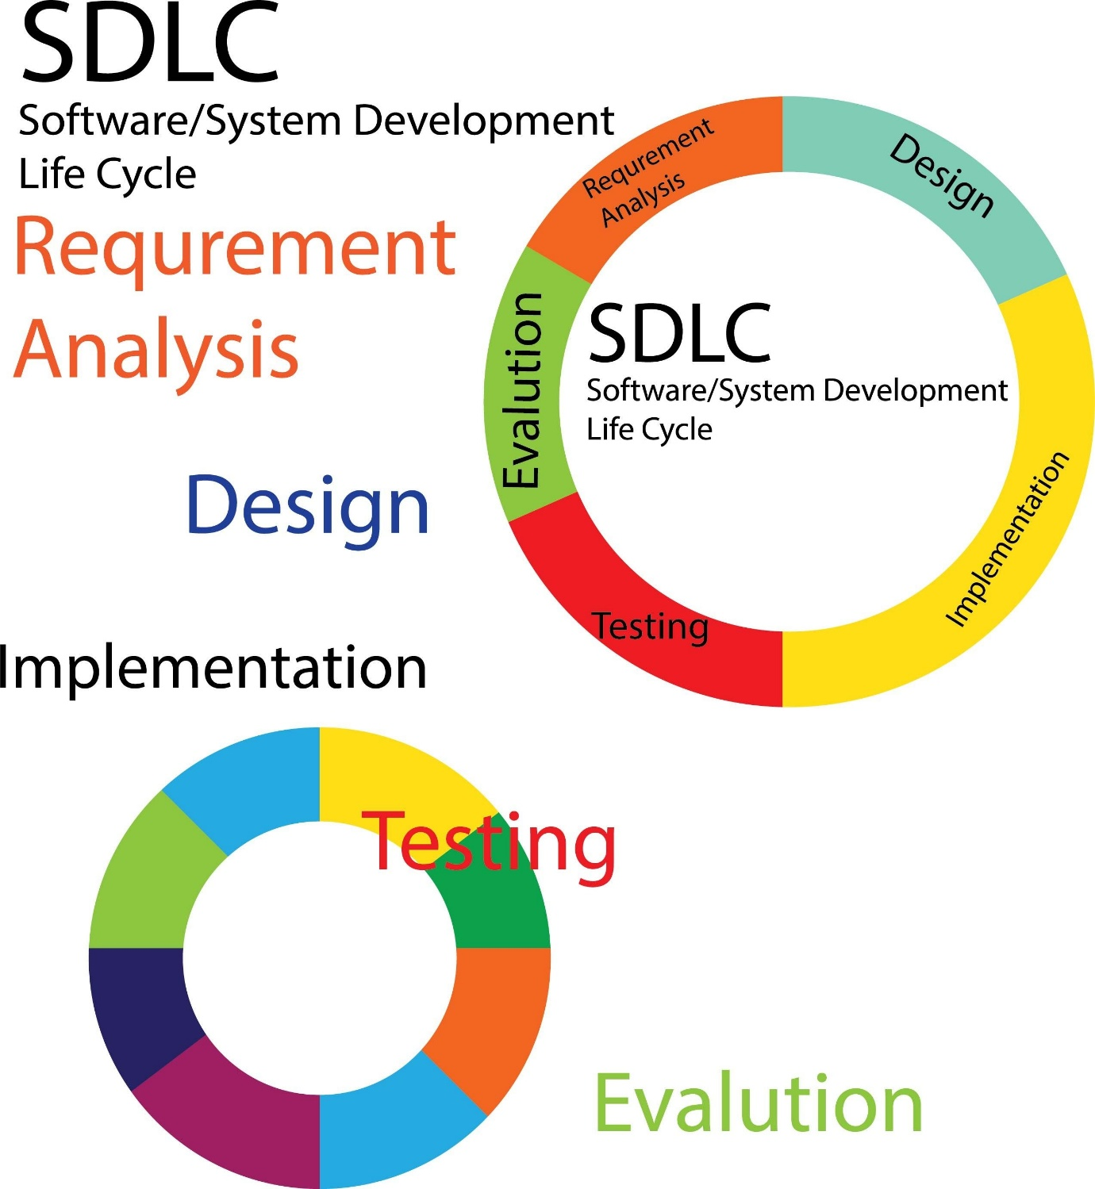
Shutterstock
2. SDLC Models
An SDLC model is a conceptual framework that arranges the SDLC phases in a specific chronological order to optimize the development cycle for different project types. Choosing the right model impacts quality, timelines, and budget.
Model | Characteristics | Best Suited For
Waterfall | Linear and sequential; phases must be completed before the next can begin. Emphasizes thorough upfront planning and documentation. | Projects with well-defined, stable, and unchanging requirements (e.g., governmental projects).
Agile | Iterative and incremental; focuses on short cycles (sprints), customer collaboration, and quick adaptation to changing requirements. | Projects with evolving requirements that require frequent feedback (e.g., customer-facing apps, startups).
Spiral | Hybrid of Waterfall and Iterative; cycles through planning, risk analysis, engineering, and evaluation. Its central focus is risk management. | Large, complex, or high-risk projects where requirements may evolve.
V-Model | An extension of Waterfall that flows sequentially but introduces a testing phase associated with every development phase (Verification and Validation). | Projects with stable requirements that need extremely high quality and early risk detection (e.g., safety-critical systems).

